**Network Fundamentals Lecture 8 Notes**

**Integrated Services Digital Networks (ISDN)**

* Integrated services digital network (ISDN)
* - Integrated services (voice data, etc)
* - Digital (no analogue link)
* - Network (the PSTN with a new digital access)
* ISDN supports multiple services by offering multiple channels
* - 64kbit/s B-channels for digitized voice
* - 64kbit/s B-channels for data (16 and 64kbit/s D-channels for ‘dialing the number’)
* ISDN may operate over the copper wire previously used for analogue transmission
* - The local loop

**ISDN Covers a range of Data Rates**

* Basic Rate Interface (BRI)
* -2B+D as shown below

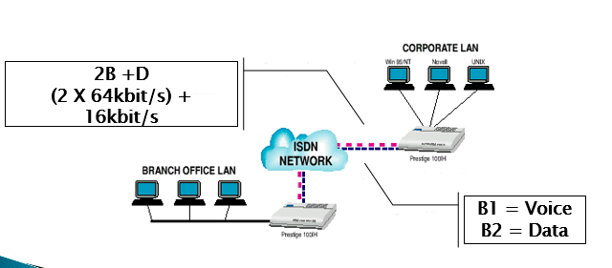

* Primary rate interface (PRI)
* - 23B + D (T1 – based)
* - 30B + D (E1 – based)

**Applications of ISDN in a Router Based Internet**

* ISDN applications take advantage of its short dial-up time
* - Usually less than a second
* Dial-on-demand
* - Dial-up as needed between two routers (close automatically after a period of non-use)
* Dial-up overflow
* - Dial-up for added capacity as needed
* - Multilink (load balancing)
* Dial back as needed

**ISDN and Video Conferencing**

* Multiple 60bit/s channels may be combined to provide an intermediate data rate
* - Such as six channels, providing 384 kbit/s
* This data rate is often used for compressed video
* - Works well for ‘talking heads’ meetings
* - Useful when people are seated (but blurs if they are walking about)
* - Definitely not ‘studio quality’ broadcast video
* Video conferencing standards include ITU H.320 and H.323

**Digital Subscriber Line (DSL)**

* Like ISDN, digital subscriber line (DSL) may operate over the existing local loop
* Asymmetric digital subscriber line (ADSL) supports different up and down channel rates
* - For example, up to 640 kbit/s uplink and 6 Mbit/s downlink
* High bit-rate digital subscriber line (HDSL) supports a symmetric flow
* - Up to 1.544mbit/s in each direction
* Actual throughput will be affected by
* - Distance
* - Quality of the copper wire
* - Quality of DSL hardware

**Asymmetric Digital Subscriber Line (ADSL)**

* Asymmetric Digital Subscriber Line (ADSL) uses frequency division
* Multiplexing
* - To support plain old telephone services (POTS) and one bidirectional data line
* Concerns include
* - ‘Always on’ security issues
* - DSLAM contention

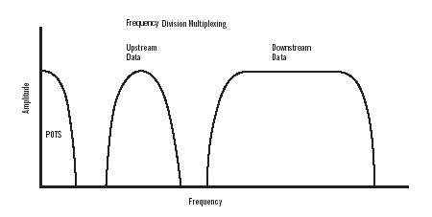

**Cable Modem**

* A cable modem data system consists of:
* - A cable TV distribution plant:

With a ‘forward path’ TV channel dedicated to data

With a ‘return path’ in the low frequency portion

The terms ‘forward’ and ‘return’ come from the usual television programming signal distribution

* Multiple subscriber modems (throughout the community)
* A cable modem termination system (CMTS)
* The CMTS controls access to the shared media data channel
* - By a request/response mechanism
* - Collisions may occur in the requests (resolved by a random backoff approach)
* Cable modem has the same ‘always on’ internet vulnerability as DSL

CMTS

Cable modem interface

Return path

(upstream)

300kbit/s to 10Mbit/s

Forward path

(downstream)

10 Mbit/s to 30Mbit/s

**European Cable Modem Service**

* There are multiple, connecting cable modem standards in Europe
* Early European modems used a technology called ‘EuroModem’
* - Building on Asynchronous Transfer Mode (ATM) cells
* More recent European cable modem use a technology called ‘EuroDOCSIS’
* - Building on IP packet transfer using the Data Over Cable Service Interface Specification (DOCSIS) (as describe in the previous segments)
* - With European –specific physical layer characteristics
* Some European cable modem services may be limited to downstream transmission
* - Using A telephone up-link channel

**Comparison of DSL and CABLE Modem Approaches**



**Error characteristics of communication circuits**

* Networking often requires ‘practically perfect’ data delivery
* - Over links that maybe of poor quality
* - We must introduce error detection and recovery (later)
* Our concern here is ‘how many frames have errors?’
* - Assume that the frame size is 100 bytes
* - Switched analogue telephones circuits 1 in 1012 frames
* There is a very large range in line quality

**Direction of Data Flow**

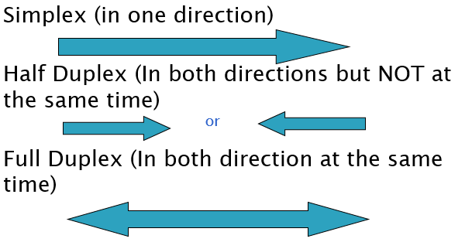

**Asynchronous Transmission**

* Asynchronous means no predefined timing between characters or other units of data
* For characters, the sending device determines when to transmit
* - The start bit indicates the beginning
* - A parity (error-check) bit is generated and sent
* - There is an arbitrary time before the next data is sent

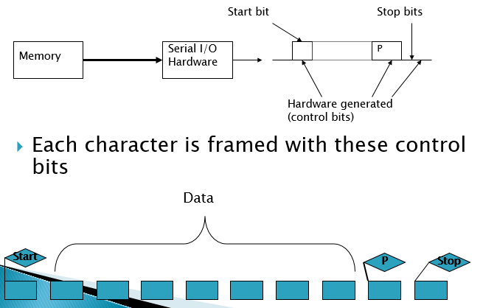

**Synchronous Transmission**

* Has a known timing relationship between bits and bytes
* Bytes are sent on after the other
* The receiver recovers timing from transitions in the arriving data

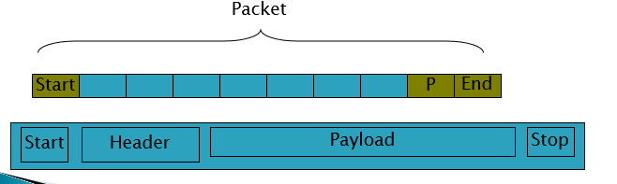

**END OF LAYER 1 – PHYSICAL LAYER**

**Data Link Layer Framing**

* With synchronous transmission, the ‘Start’ and ‘End’ must be indicated
* - While still being able to send arbitrary data patterns
* - This is ‘the framing problem’
* There are many different technical solutions
* - All of them bound the unit of data
* - Much like a picture ‘frame’ bounds a painting

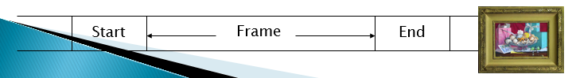

**High-level Data Link Control**

* The HDLC header indicates the frame type
* - User data frames
* - Control frames
* There are two different types of control frames
* - ACK and flow-control frames (RNR and RR)
* - Connection controlhttps://i.gyazo.com/0f43b62903312985c3437f31f8b6c8e6.png

**HDLC Frame**

